Task1 – Frontend website
a) Please report up to 3 bugs or flaws

Bug#123
Bug id - #123
Name - [View deals] – Deals not displayed & Number of adults not updated
Reported By- Vigneshwaran Ravindran
User story associated- US_003
Date- 02.03.21
Severity- Critical
Environment- Chrome Version 88.0.4324.190
AssignedTo- Developer1
Status- New
Fix expected by- 10.03.21
Application build#- v2.1.2
Origin- Exploratory test

Summary:
The deals are not displayed/ loaded when the number of adults are set to maximum(48) and then normal adults count(2) is inputted through keyboard.

Steps to Reproduce:
+ Go to trivago discover page https://discover.trivago.co.uk/
+ Enter Random - City location – Select Radius – Stay dates
+ Click on the Guests tab
+ Enter the number of adults 48 – Children 0
+ Click Apply
+ Click on Guests tab again
+ Click on Adults input box and enter 2 using keyboard
+ Click Apply

Expected Results:
+Deals are displayed/reloaded automatically for the new number of adults(2) after clicking Apply
+ Number of adults in the input text box of adults updated to 2

Actual Results: Refer the attached gif below
+ No new deals are displayed for the new number of adults 2
+ Number of adults is not updated to 2 from 48
+ Number of adults still shows as 48 instead of the user input 2

#123_1 – Refer the attached gif
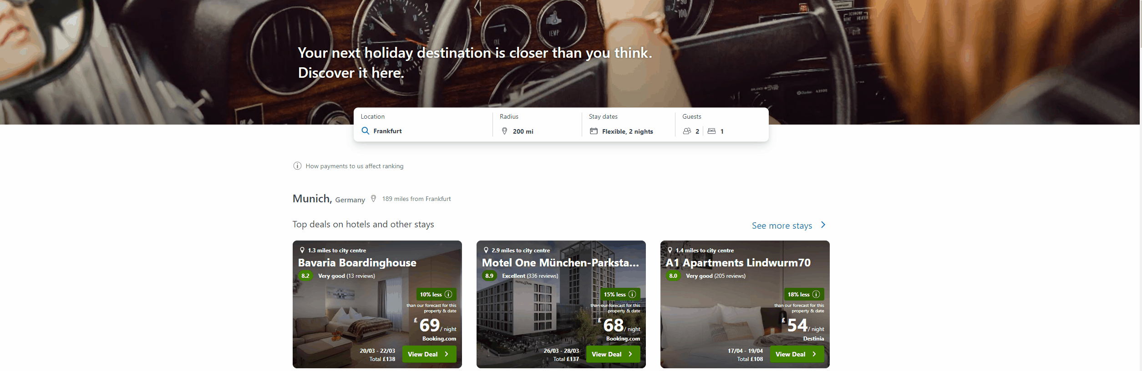

Bug#234
Bug id - #234
Name - [Guests Tab] – Combination of 1 Adult – 1 children – 2 Rooms couldnt be set
Reported By- Vigneshwaran Ravindran
User story associated- US_002
Date- 02.03.21
Severity- Critical
Environment- Chrome Version 88.0.4324.190
AssignedTo- Developer2
Status- New
Fix expected by- 10.03.21
Application build#- v2.1.2
Origin- Exploratory test

Summary:
The guests input combination of 1 Adult – 1 children and 2 Rooms couldnt be set in the guests tab

Steps to Reproduce:
+ Go to trivago discover page https://discover.trivago.co.uk/
+ Enter Random - City location – Select Radius – Stay dates
+ Click on the Guests tab
+ Input the number of Adults as 1 using „“-“ button
+ Input the number of children as 1 using the „“+“ button
+ Input the number of rooms as 2 using „“+“ button

Expected Results:
+ Total number of guests should be 2 (1 adult and 1 child) and 2 rooms
Actual Results: Refer the gif below
+ Number of adults automatically get updated to 2 from 1 on clicking the Room + button

Attachments: #234_1
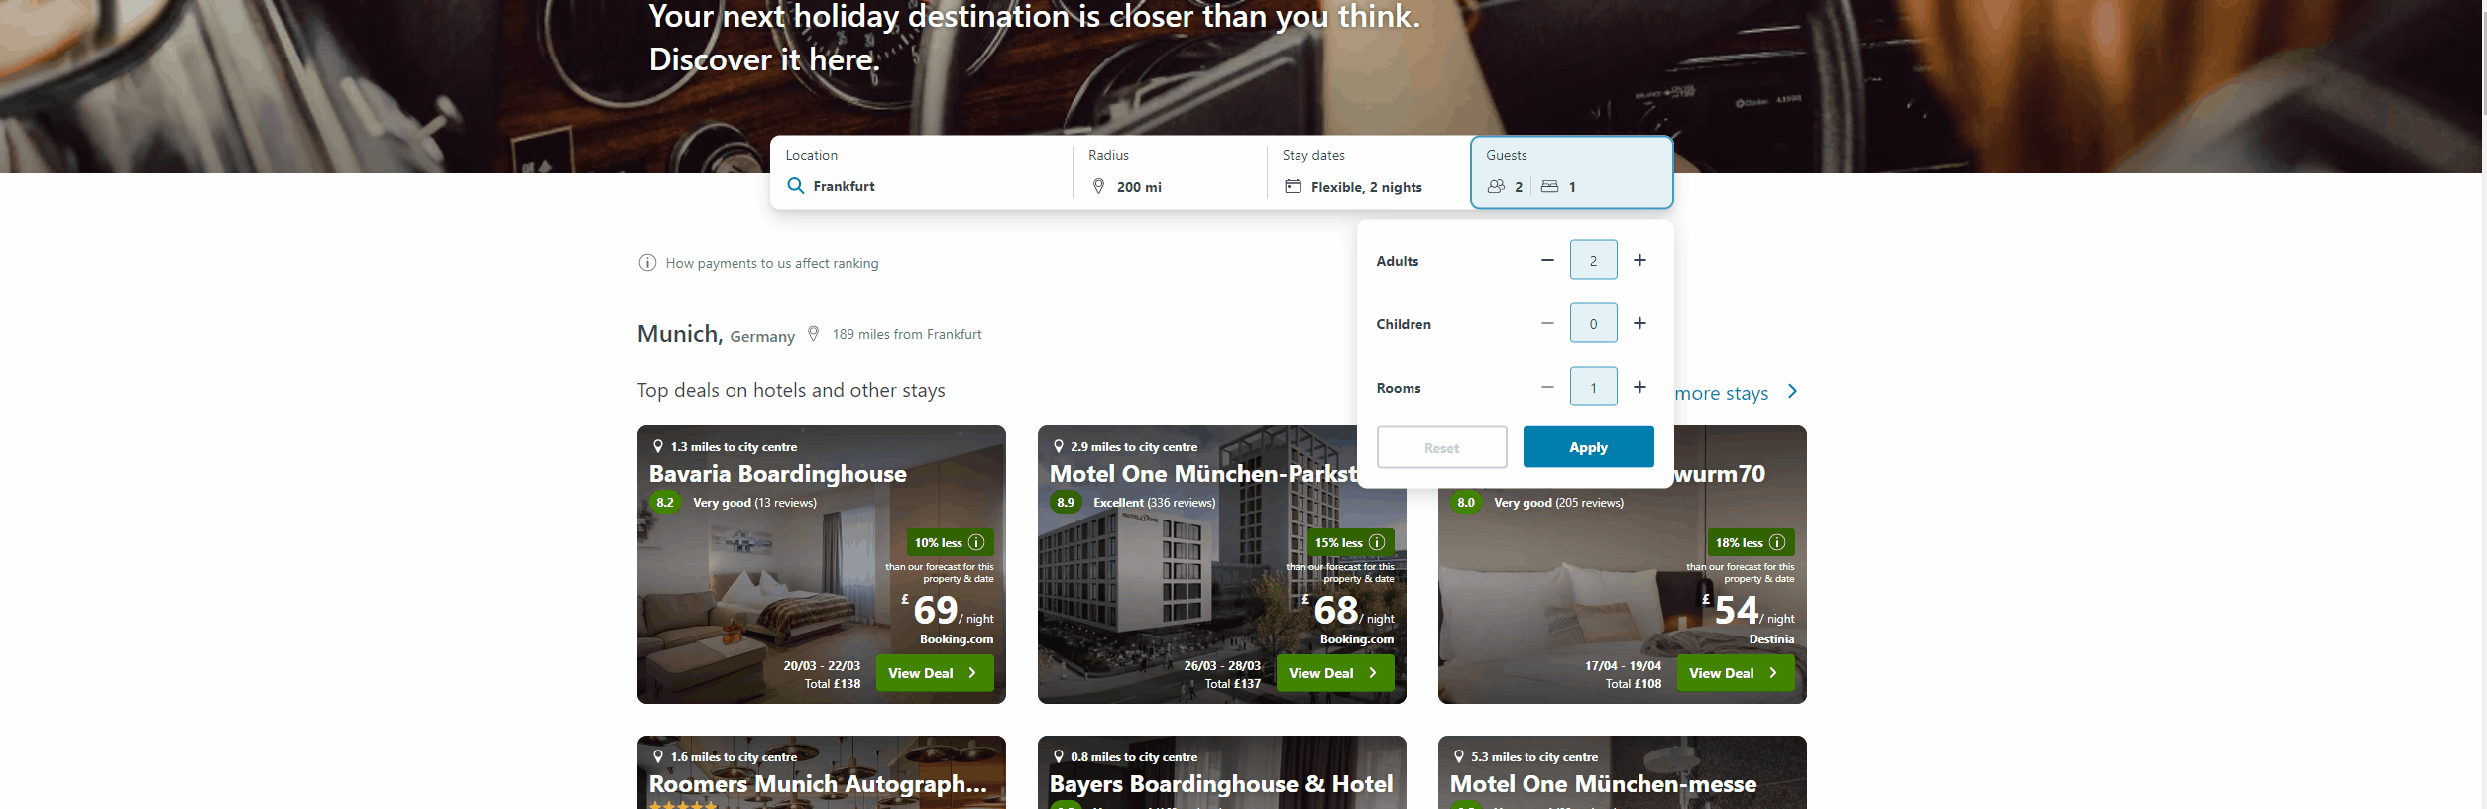
Bug#345
Bug id - #345
Name - [Stay dates] – Combination of Next14 days and the last option(May) displays deals only for the Month of May
Reported By- Vigneshwaran Ravindran
User story associated- US_002
Date- 02.03.21
Severity- Critical
Environment- Chrome Version 88.0.4324.190
AssignedTo- @Developer2
Status- New
Fix expected by- 10.03.21
Application build#- v2.1.2
Origin- Exploratory test
Clarifications- @ Business Analyst – change the flow such that user can select one of the checkboxes in the Stay dates ????

Summary:
Stay dates combination of Next 14 days and the last month option(May) displays deals only for the Month of May

Steps to Reproduce:
+ Go to trivago discover page https://discover.trivago.co.uk/
+ Enter Random - City location – Select Radius
+ Click on Stay dates
+ Select the checkbox „“Next 14 days“ and „“May“
+ Input random number of Nights
+ Click Apply
+ Input the number of Adults 2 – Children 0 – Rooms – 1
+ Click Apply

Expected Results:
Deals should be populated for both the selected Date ranges of Next 14 days and May month

Actual Results:
Deals are displayed only for the month of May and Not for next 14 days even though the option was selected in the Stay dates tab

Attachments: #345
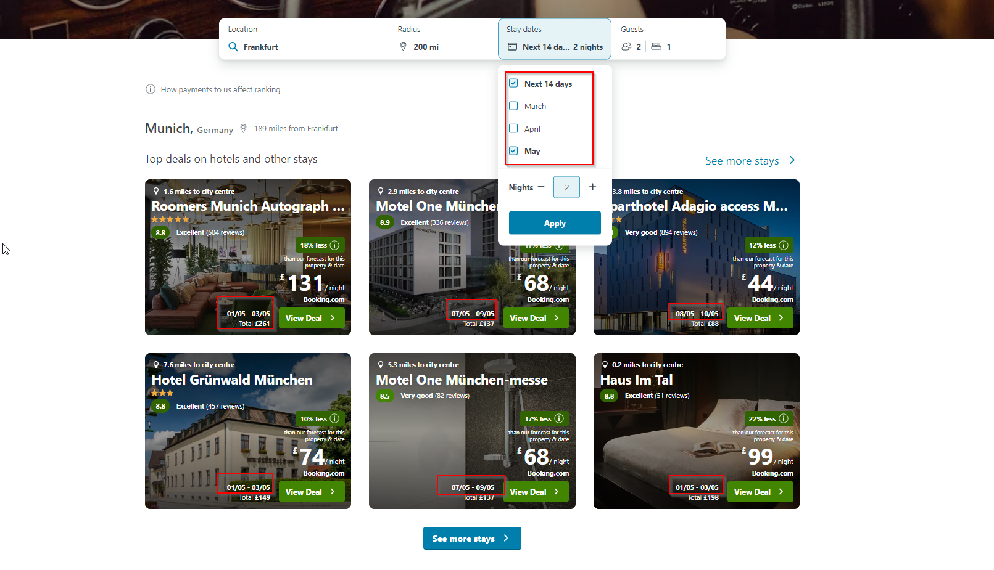

b) Brief overview on Pre release testing
Given the short duration of 1 hour for the pre release testing as a QA engineer I would priortise my testing the way listed below
> Perform Smoke testing – Covering the most import functionalities of the application
> Perform E2E Functional testing – covering the main business workflows of the application
> Test the new features that were developed during release
> Ensure the blocker defects that were created during the release are fixed and works fine

How to determine if it is ready to be released or not?
> If there are no new blocker defects arising during the above test process and the previous found /existing blockers defects are fixed and working fine
> If the E2E scenario test cases worked fine
> If the new features developed for the release are intact and working fine
Then the its a good to go release candidate and the software can be released

Which aspects do you need to consider when testing the trivago website?
> Consider Discover feature is the developed for software release and pre release testing of trivago‘s website would look like
> Testing the functionality of hotel search
> Testing Navigation to other reservation site on View deals functionality
> Testing if availability and reservation workflow is working fine
> Testing if the Guest details forms are saved correctly in the DB and UI
> Testing the payment process and sending of confirmation email work flow
> Testing the main feature for the release – Discover functionality
> Testing view deal workflow under Discover tab
> Test availability , reservation & payment process

c) 3 examples of release blocker (specific to Trivago)
Blocker #1 – Hotel Search tab
> Given when an user inputs City name, Check and check out date , number of guests and rooms and clicking on Search doesn‘t return any Hotel deals
Blocker #2 – Discover tab View tab
> Given when an user inputs location , Radius , Stay dates and Guests – Results are populated with View Deal button – Clicking on View Deal button leads to Page Not found 404
Blocker #3 –Incorrect Stay dates on external site – View deal
> Discover tab > Enter location , radius, Stay dates etc > View deal > Page navigation to external site > Incorrect stay dates and number of guests on the external site (Booking.com)

Task2 – Bounce rate Analysis
Please analyze the data, explain your conclusions and what steps you would take to further investigate the possible causes (assuming you were working in QA at trivago).

Analysis:
>Confirm if the versions of firefox used in the data analysis of Australia and Brazil are same or different
>The bounce rate has been increasing linearly over time and has reached its peak on 22.4.2019 and is unsually high specifically for the Australia Desktop firefox users which leads to have a deeper investigation for the cause.
>Install the specific firefox browser version and try to analyse and come up probable causes for the issue. Assuming the firefox versions used for the data analysis of bounce rates between Brazil and Australia are the different
- Bad content / Target Audience not receptive ?
Ruling out Bad content & target audience receptiveness because the bounce rate for other browsers in Australia have been more or less constant over the time period, only firefox has this issue of linearly increasing bounce rate over the time frame.
Narrowing down the issue to browser specific version
- User experience in the specific version of Firefox Australia
Make sure to check the user experience in the specific firefox version in Australia is lean and easy to use
- Technical Error
Probably trivago‘s site Javascript malfunctioned in the specific version of firefox or a plugin went down leading to forms not loading in the Site.
- Speed Issues
Use tools like Gtmetrics to get a glimpse of the website‘s speed on the specific firefox browser version

Steps
- Identify and segregate the one specific page which might be causing the unusal bouncing rate in the specific firefox browser version using the metrics like Number of visitors- Average pages per visit- Time on site from google analytics
- Once the page is identified look at page‘s design, navigation and content. Determine if the page is at the best it could be and if the user/visitor goals are met .
- Install a recording tool to analyse the Users navigation through the website in the firefox browser and identify the page with excess bounce rate in the firefox browser.
- Use Heatmap visualisation on the specific page causing the high bounce rate and analyse the spots where the users are not engaged
- Redesign, adjust and optimise the places in the specific page causing the high bounce rate and perform A/B test and determine the improvement.
- Try some multivariate testing as well and gather the performance
- Implement the optimisation and assess the visitor engagement

Conclusion:
- If the spike in bounce rate for the firefox browser is because of the User experience, Javascript malfunction or break of a plugin fix them and analyse the bounce rate again for improvement
- If the bounce rate is because of a specific page issue on Trivago‘s site identify the page using metrics and redesign, adjust and optimise the page performing repeated cycles of A/B testing and optimisation.

Task3 – Discover user flow automation

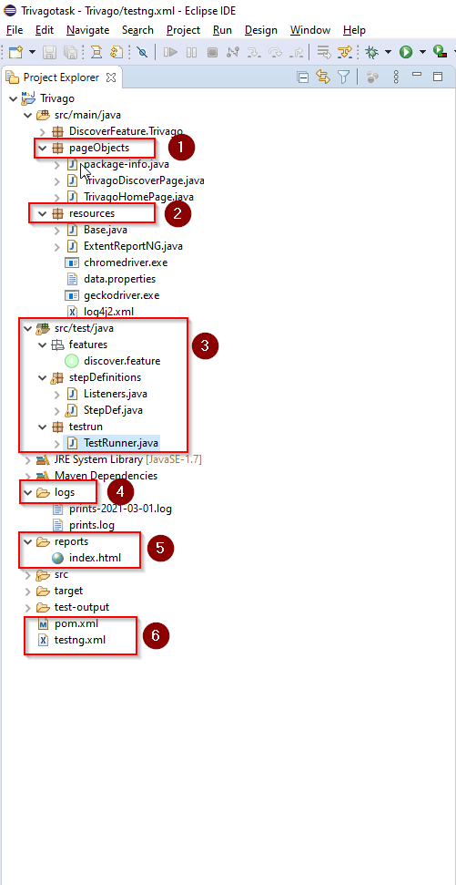

The test automation has been developed in Cucumber BDD framework
- pageObjects folder
Will contain all the locators of elements in each page and methods which will return the elements
- resources folder
Base class will initialise the Webdriver used for running the automation
Folder also Will contain the driver.exe files and the method for initialising the browser.
User can add the urls and type of browser the automation has to run in the data.properties file
- features package
will contain the discover feature thats automated – data parameterisation is also done making sure a single test achieves checking all the buttons, tabs working and combination of values that could be tested on the Discover feature.
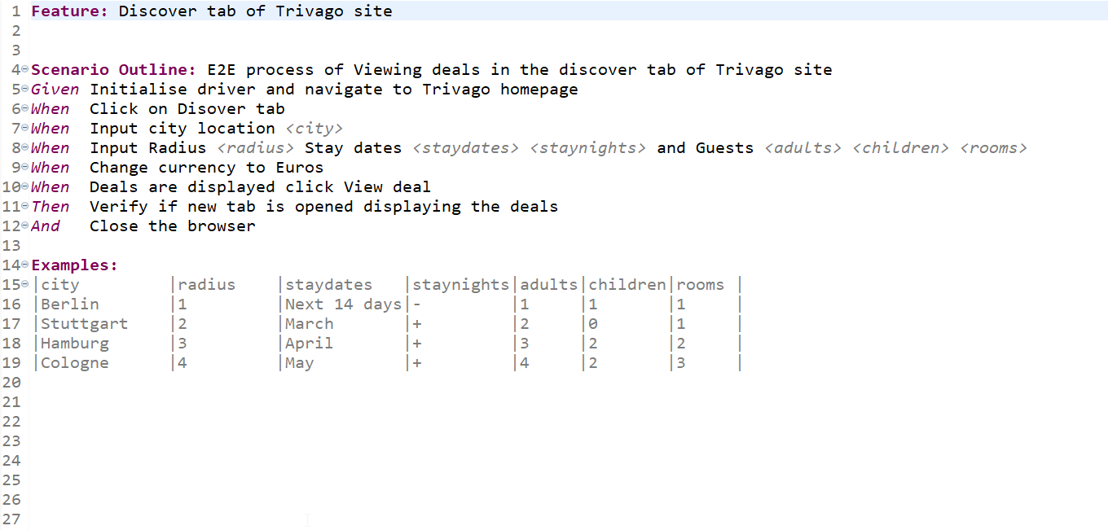
3.1 Stepdef package
Will contain the code implementation of the feature steps

4. logs
generated log files are stored in this folder with all the log info

5. reports
Extent report about the test passed and failed can be viewed under this folder

Executing the automation test case:
Make sure to have enviroment and path variables configured for Java , Maven

Method1 - TestNG:
> Download the folder > Import the project folder Trivago in any IDE of your choice >
> Open the testng.xml > Run as testng suite > View reports

Method2 – mvn
> Open command prompt > CD path to the Trivago folder
> mvn compile
> mvn test
> Will run 4 scenarios based on the data parameterisation

